GROUP MANAGEMENT &

PERMISSIONS

Q1. For the user edu,how will you change the primary group to root and secondary to edureka?

ANSWER : 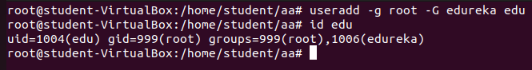

Q2. Create a testfile and change its ownership to user eduand group edureka

ANSWER : 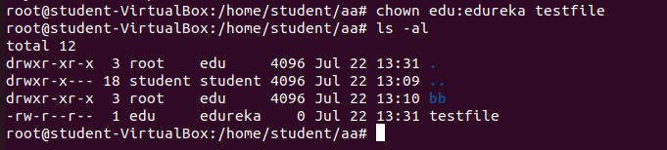

Q3. How will you provide read write execute permissions for the user, read and write to group and execute to others for theabove

created file “testfile”?

ANSWER : 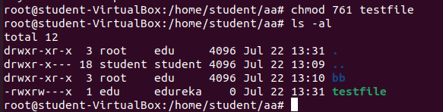

Q4. How will you delete the user edu along with its home directory and also remove its secondary group edureka?

ANSWER: 

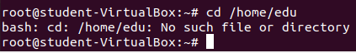

Q5. How will you add a new group named

saleson the server with id group id 2001?

ANSWER: groupadd –g 2001 sales

